Phase 1:
Database->simply collection of organized data ,that can be easily accessed ,managed and updated
It store data electronically
Rdbms->Relational database management system
Sql vs no sql->
Sql-postgresql,oracle,mysql no sql->mongodb
Save all as table save all as objects
Postgresql-opensource ,support complex query,
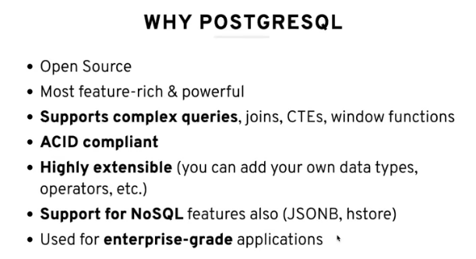
Compare to othersঃ
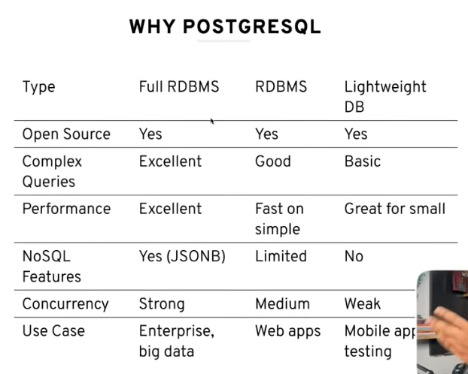
Now Install Postgres sql
Then Pg Admin 4
Password:1234 port:5432
To run in shall cmd te (SQL SHALLL) type kore 4 bar enter then password dilei done
\l ->dile available database ja ase sob show korbe
In database there will be schema
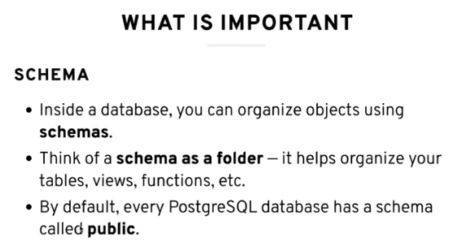
In schema we can create multiple table
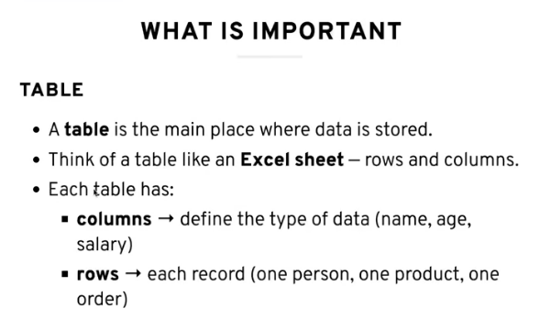
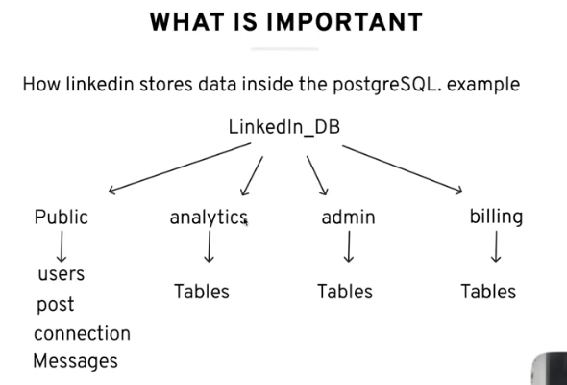
How linked in work

Phase 2->
Basic command and crud operation:
In shall: Create Database database_name; new database will be created
Same things you can done in query tool
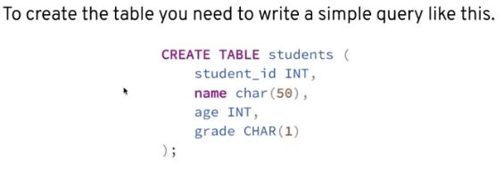
Ei same jinis shall e connect korte command : \c database_name;
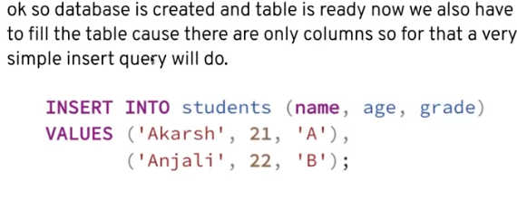
Now for seeing your data use
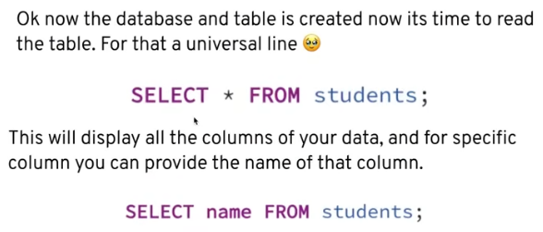
Filter using
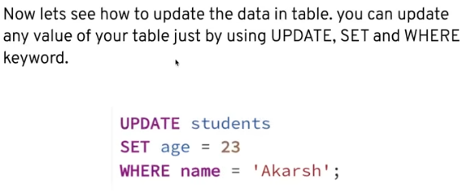
Update : 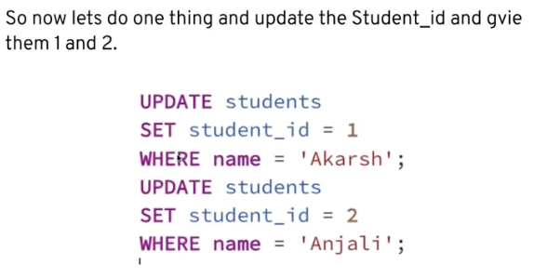

Delete:
Now we faces some problem here :
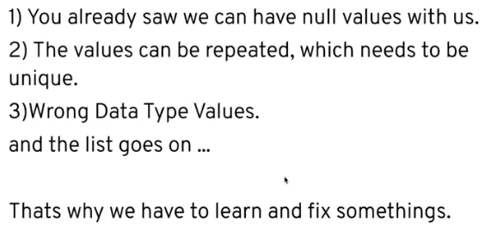
Phase 3:
Appropriate datatype and constraints:
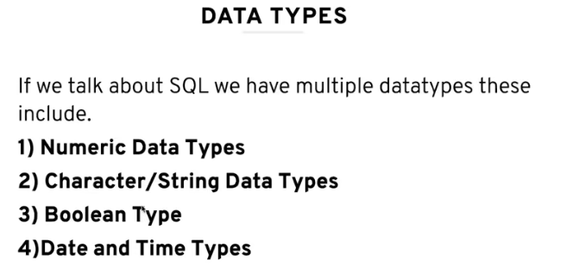
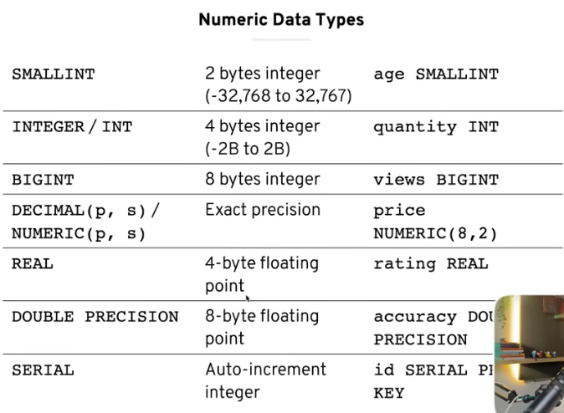All numeric datatype
If we don’t follow this kind of error we can face
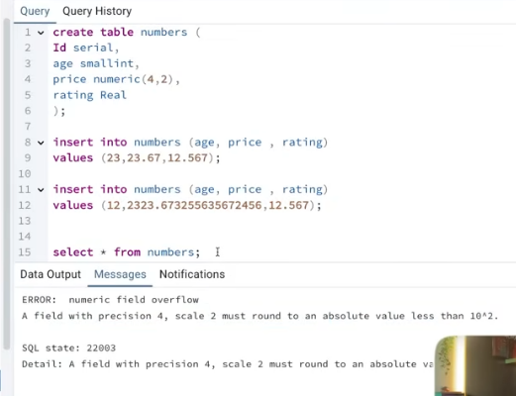
Now character datatype:
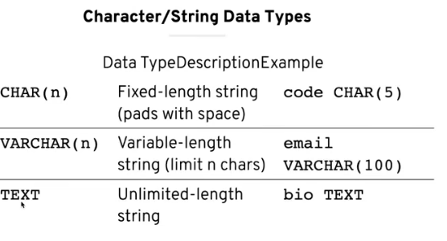

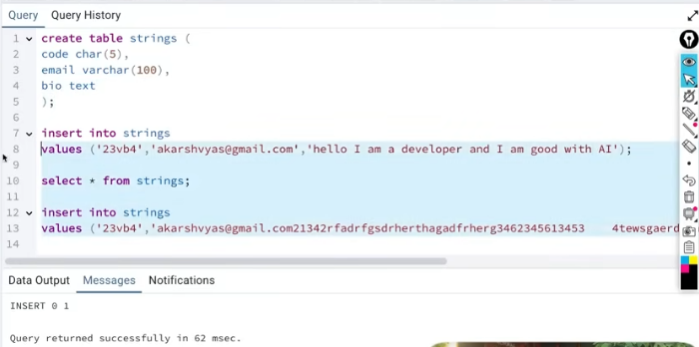
How to use string datatype
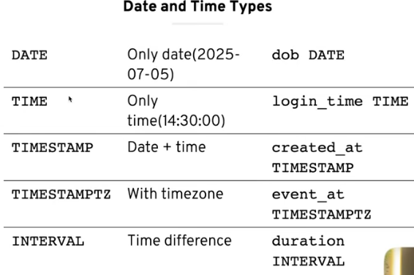
Boolian and Date and Time Type:
Now constraints:
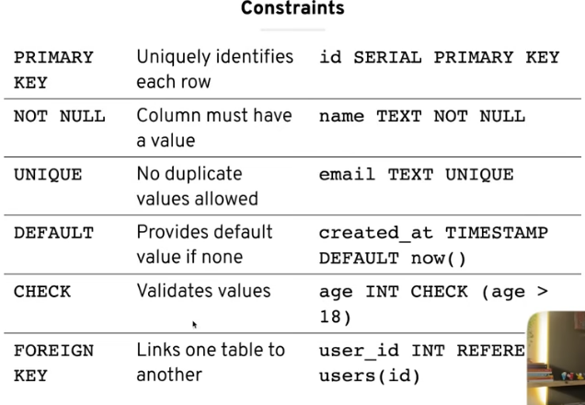
How to use:
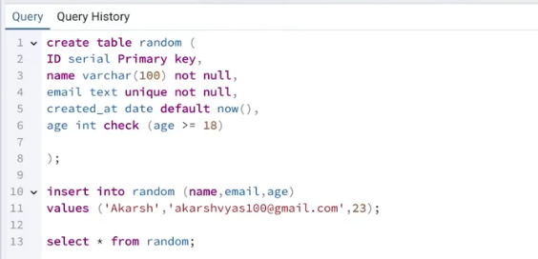
Now practice
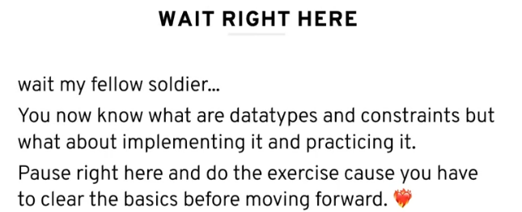
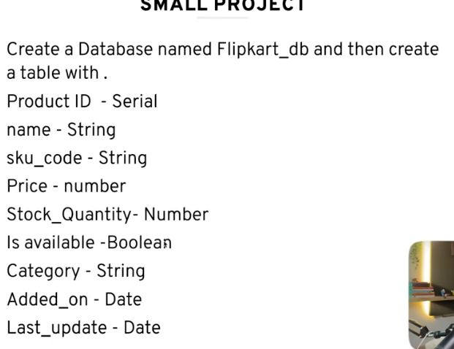
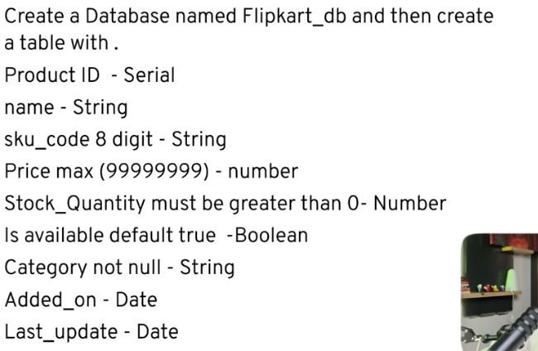
Practice this 2 project first make it then see answer:
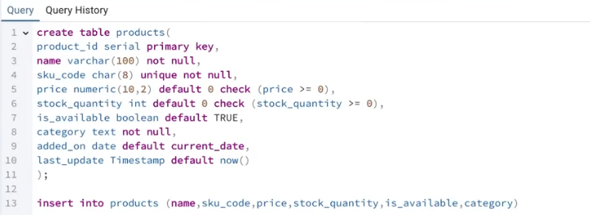
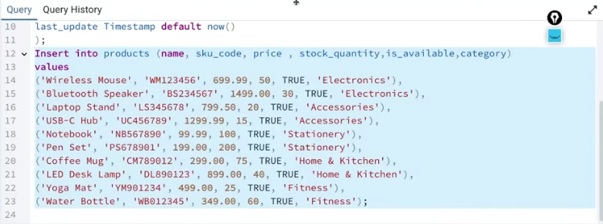
Some problem:
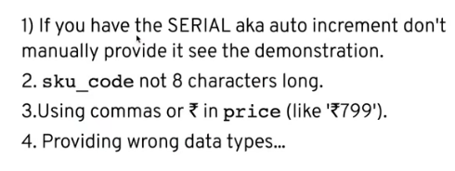
1.
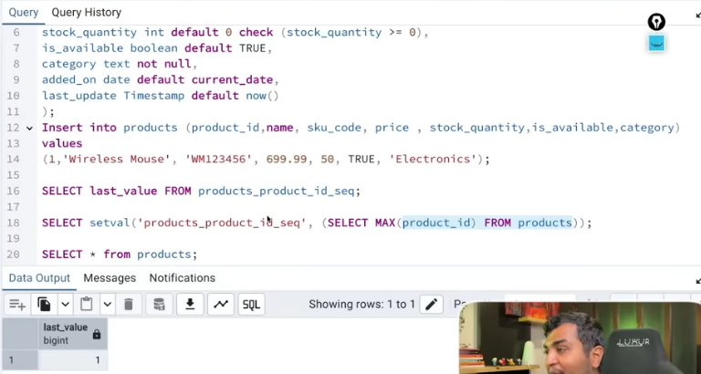
2.
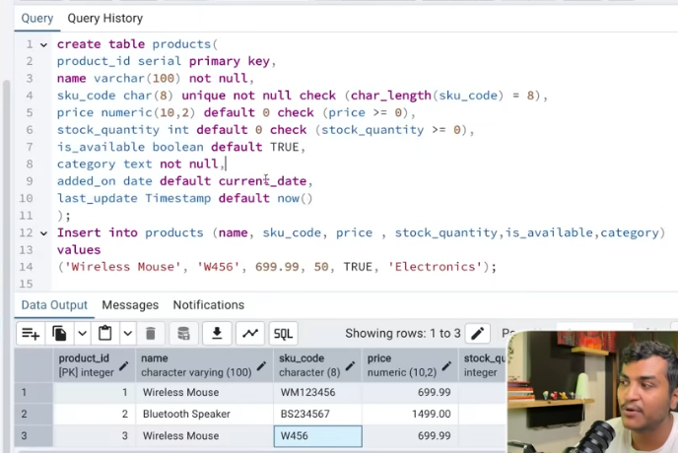
Phases 3 :
Clauses ,Operators and aggregation functions->
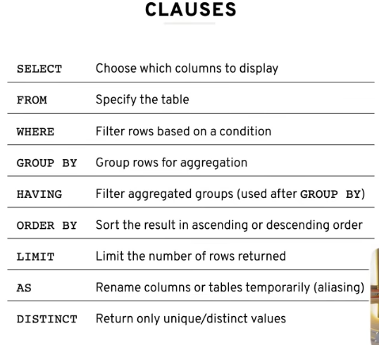
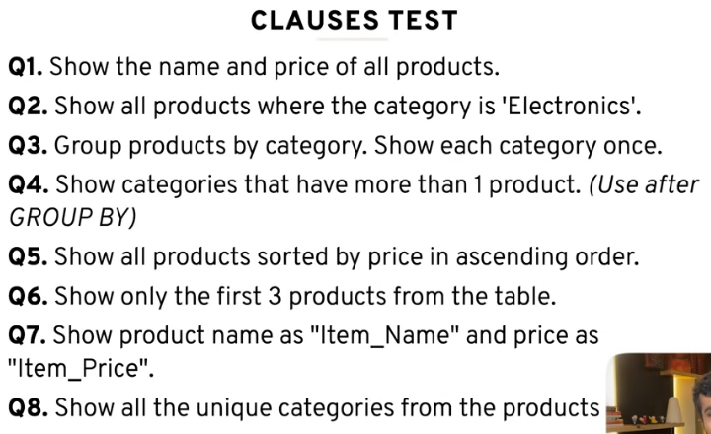
1.select name ,price from products;
2.select * from product where category=’electronics’;
3.select category from products group by category;
4.select category, count(*) from products group by category having count (*) > 1
5.select * from products order by price Desc;
6.select * from product limit 3;
7.select name as item_name ,price as item_price from products;
8.select distinct category from product;
More important:
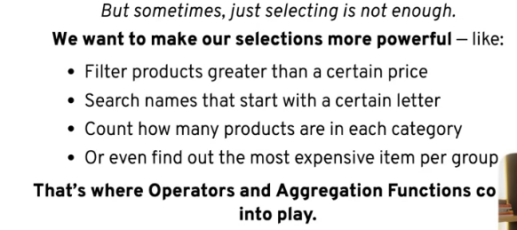
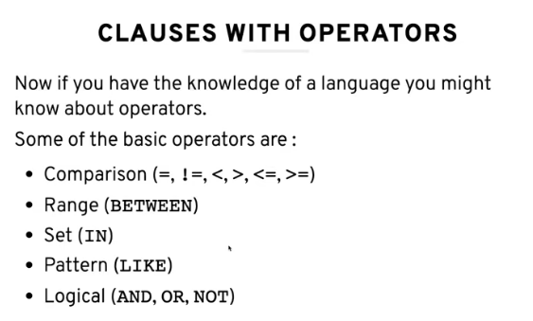
With this we have to practice problem
Practice a lot from LIKE ;
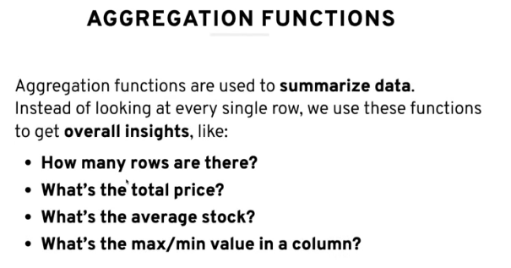

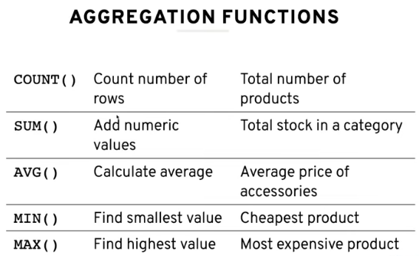
Test 2:
